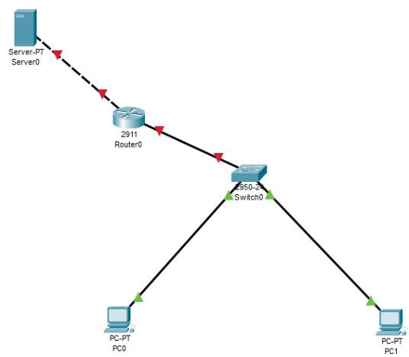

Assigned a static IP address to the server.Server: IP address: 192.168.1.2 Subnet mask: 255.255.255.0 Default gateway:

192.168.1.1

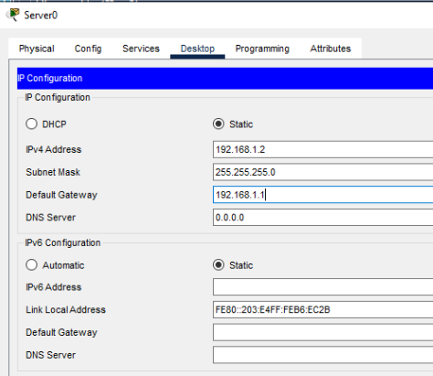

Router interface configurations

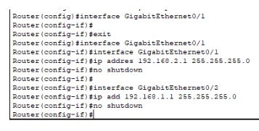

DHCP Server->Services->DHCP.

Turn ON the DHCP service on the server. We’ll configure DHCP server pool

named SALES on the generic server (Located on the network 192.168.1.0/24). This pool

will provide IP addresses to hosts in SALES LAN (Network 192.168.2.0/24). Here we go:

Pool Name: SALES Default Gateway: 192.168.2.0 DNS server: 192.168.1.2 Start IP

address: 192.168.2.0 Subnet Mask: 255.255.255.0 Maximum no. of Users: 255

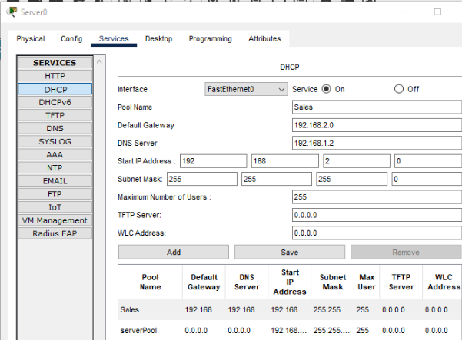

Add the command ip helper-address 192.168.1.2 on the interface configuration mode

of fa 0/1 of Router , just as we’ve done before.

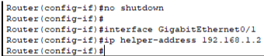

6. Lastly enable DHCP on the PCs in SALES LAN. The PCs will obtain their address from

the DHCP server.

